University of Canberra

Faculty of Science and Technology

**Mobile Technologies (11492 & 9076)**

**Assignment 1**

**Location Tracker – Android Mobile App**

**Submission date: 23:59 Friday ~~10/03/2023 (Week 5)~~ 17/3/2023 (Week 6)**

**Type:** Individual assignment

**Total marks: 16**

**Submission:** Submit a compressed (.zip) file that contains your entire Android Studio project to the submission box for Assignment 1 on Canvas site of this unit. Email submission is not accepted.

**Late submission:** 5% of the total marks (i.e., 0.8 mark) per day.

**Task: Implement an Android mobile app for tracking locations with the requirements listed below**

The user can use this app to find street address and GPS coordinate (latitude and longitude) of the current location (or last known location if the user is moving). The user can also use this app to view the current location and 5 nearby interesting places on the Google map and street views of these locations. Below are the requirements and screenshots for this app.

**Requirements**

1. Use **Android Studio** with **Java** language and **Google Maps Activity** template to create this project.
2. This project name is **Location Tracker**.
3. There are two activities which are **MainActivity** and **MapsActivity**. The project starts with MainActivity.
4. Other requirements can be found below with their screenshots.

**Screenshots** that show how the app works are listed below (they are from **Pixel 6 Pro API 33** emulator, however you can use other emulators or phones to run this app).

* Start the app on an emulator or phone. There are 3 buttons and an image on this main activity. Note the designs for portrait mode and landscape mode are different.

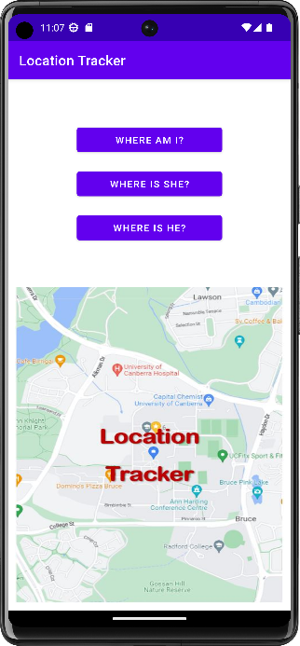 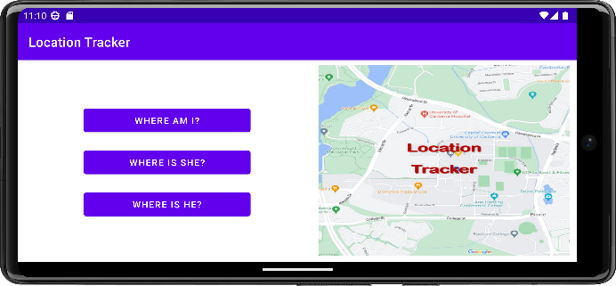

* + The activity title is **Location Tracker**.
  + The 3 buttons have the same size, same left constraint, and same right constraint. The button height is set by default. Use the phone width to estimate the button width and all 4 constraints.
  + The first button (Where am I?) has a click event listener that will open the maps activity when the button is clicked.
  + The second and third buttons have no event listener. They are for the second assignment when the app can get location data from a cloud database.
  + The image is just for design, you can use your own image. However, the image view must have the same **8dp** margin (left, bottom and right in portrait mode, and top, bottom and right in landscape mode).
* The user clicks the **Where am I?** button. The following map activity will appear:

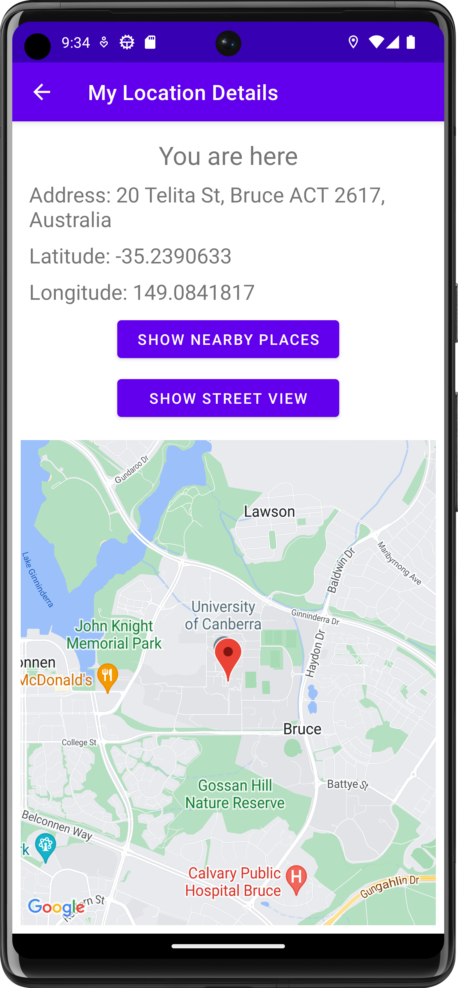 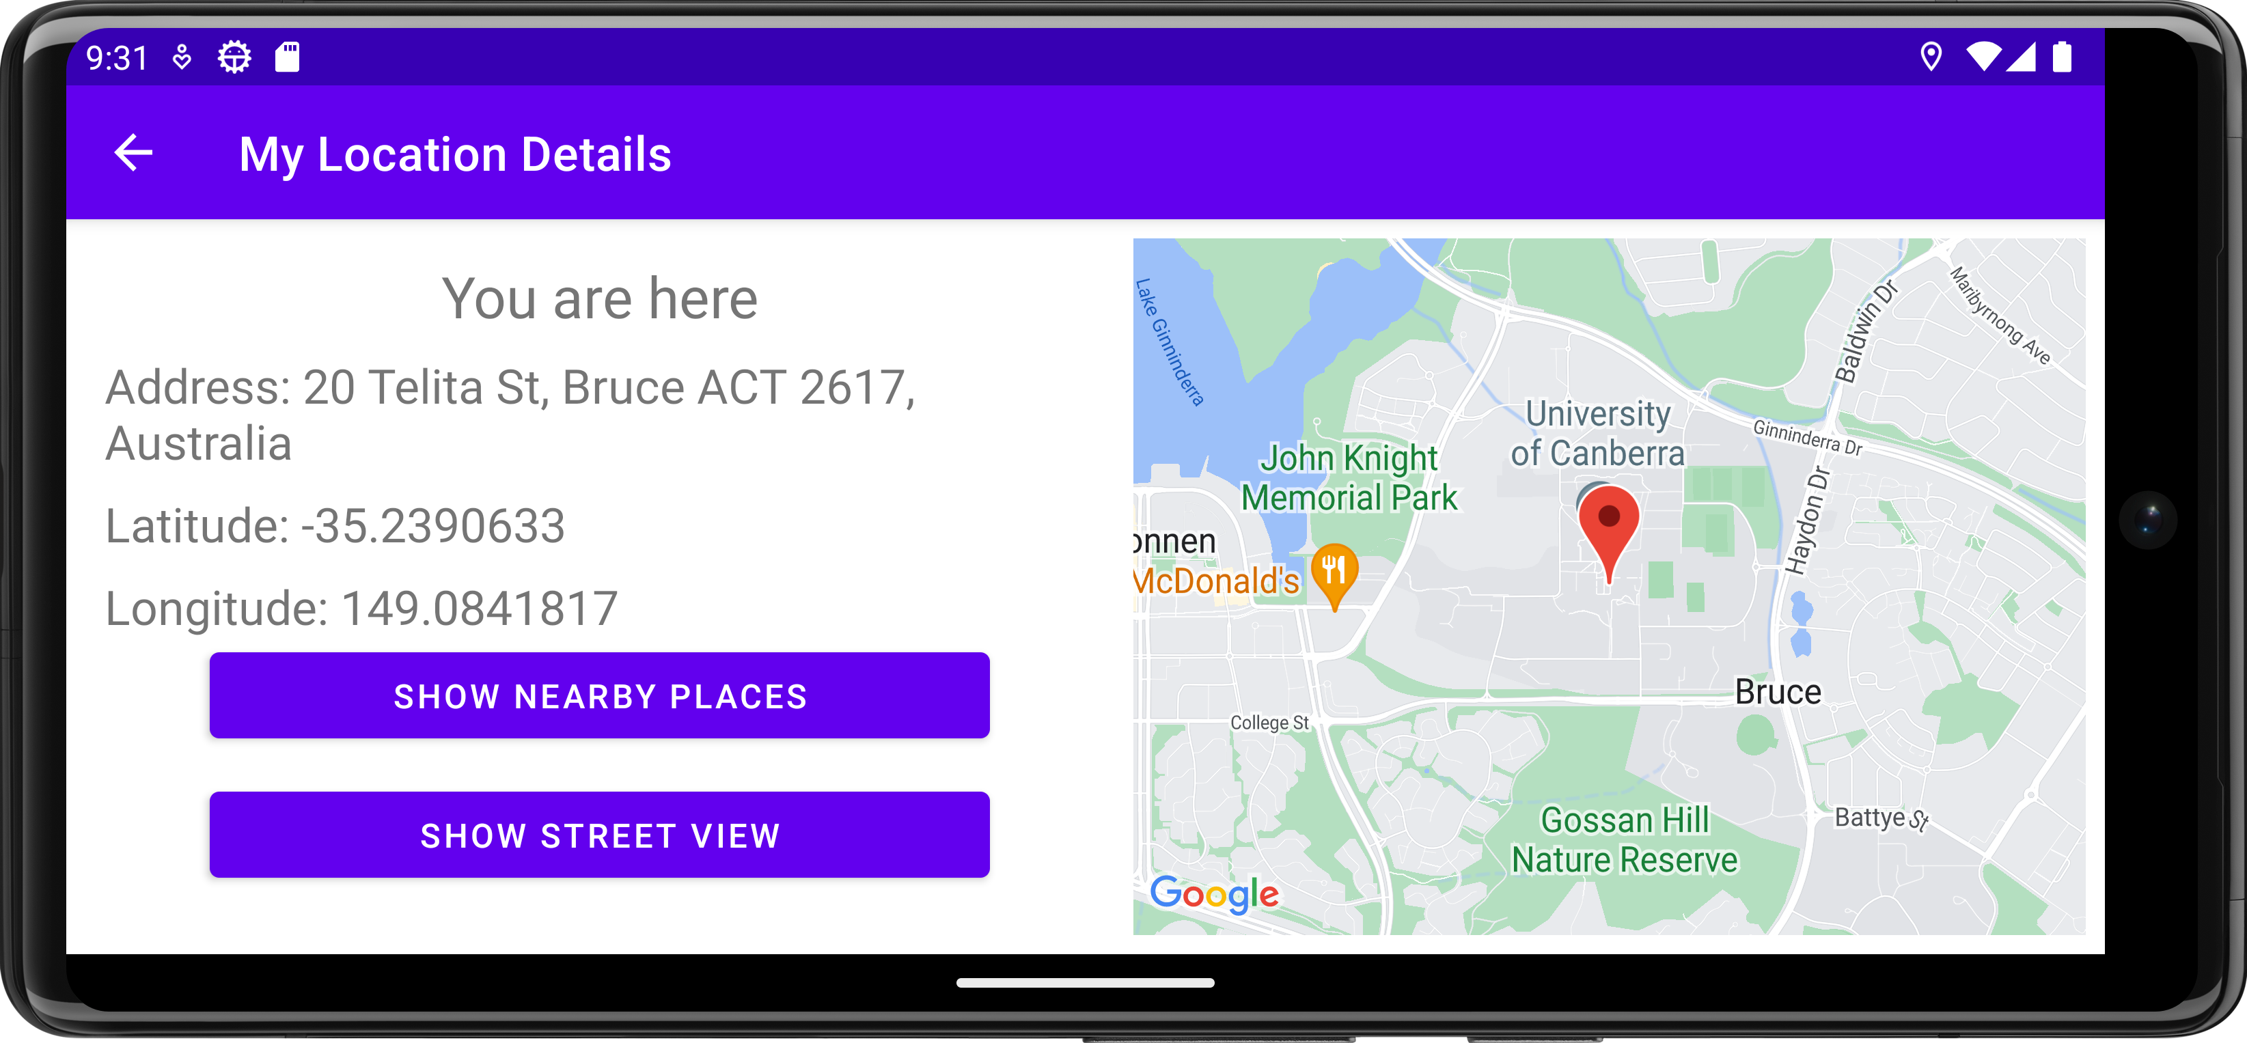

* The activity title is **My Location Details**.
* The back arrow **←** button is to open the main activity when this button is clicked.
* The first text view shows **You are here**.
* The second text view shows **Address: abc** where abc is the current address.
* The third text view shows **Latitude: x** where x is the current Latitude number.
* The fourth text view shows **Longitude: y** where y is the current Longitude number.
* The left margin for all 4 text views is **16dp** in both portrait and landscape modes.
* The two buttons must have the same size, same left constraint, and same right constraint. The button height is set by default. Use the phone width to estimate the button width and all 4 constraints.
* The map view has the same **8dp** margin (left, bottom and right in portrait mode, and top, bottom and right in landscape mode). It must display the map with a red marker at the current location of the phone. In the screenshots below, the current location address is 20 Telita St, Bruce, ACT 2617, Australia (at UC Bruce campus). You can use different locations to test your app.
* If the user clicks on the red marker, the app will hide the map view and show the street view for that current location, and at the same time, the second button also changes its label from **Show Street View** to **Show Map**. If the user clicks on the second button labelled **Show Map**, the app will hide the street view and show the map view for the same current location, and at the same time, the second button also changes its label from **Show Map** to **Show Street View**.
* The street view has the same size and margins with the map view.

 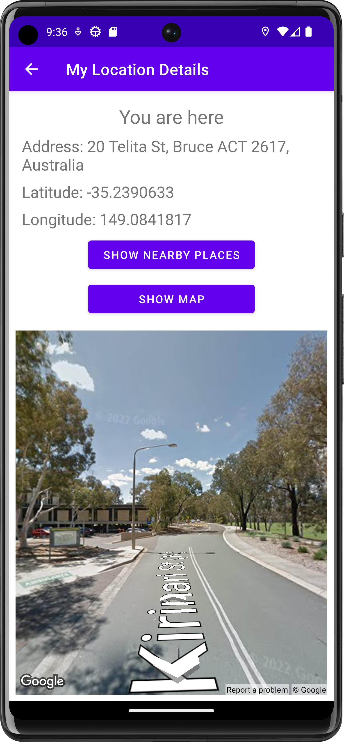 

*The user clicks the marker then clicks the Show Map button*



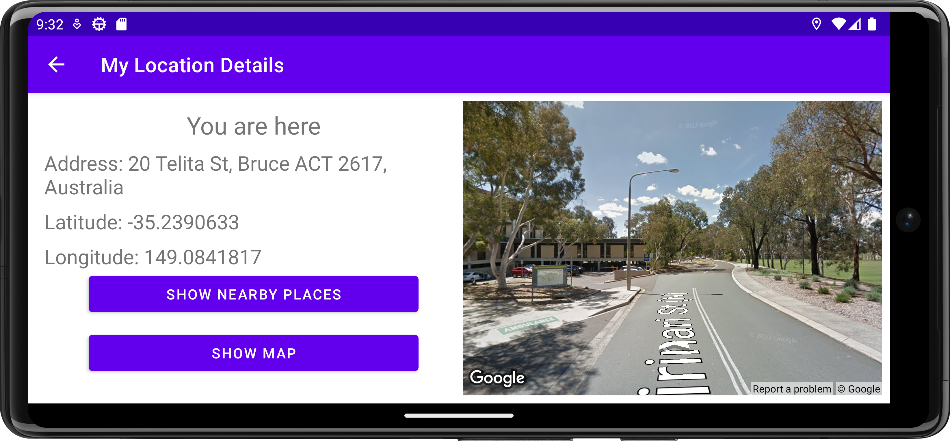



*The user clicks the marker then clicks the Show Map button*

* If the user clicks on the first button (**Show Nearby Places**), the map will show 5 additional blue markers for the nearby places (businesses and other points of interest). Note: you need to display the map at the greatest possible zoom level.

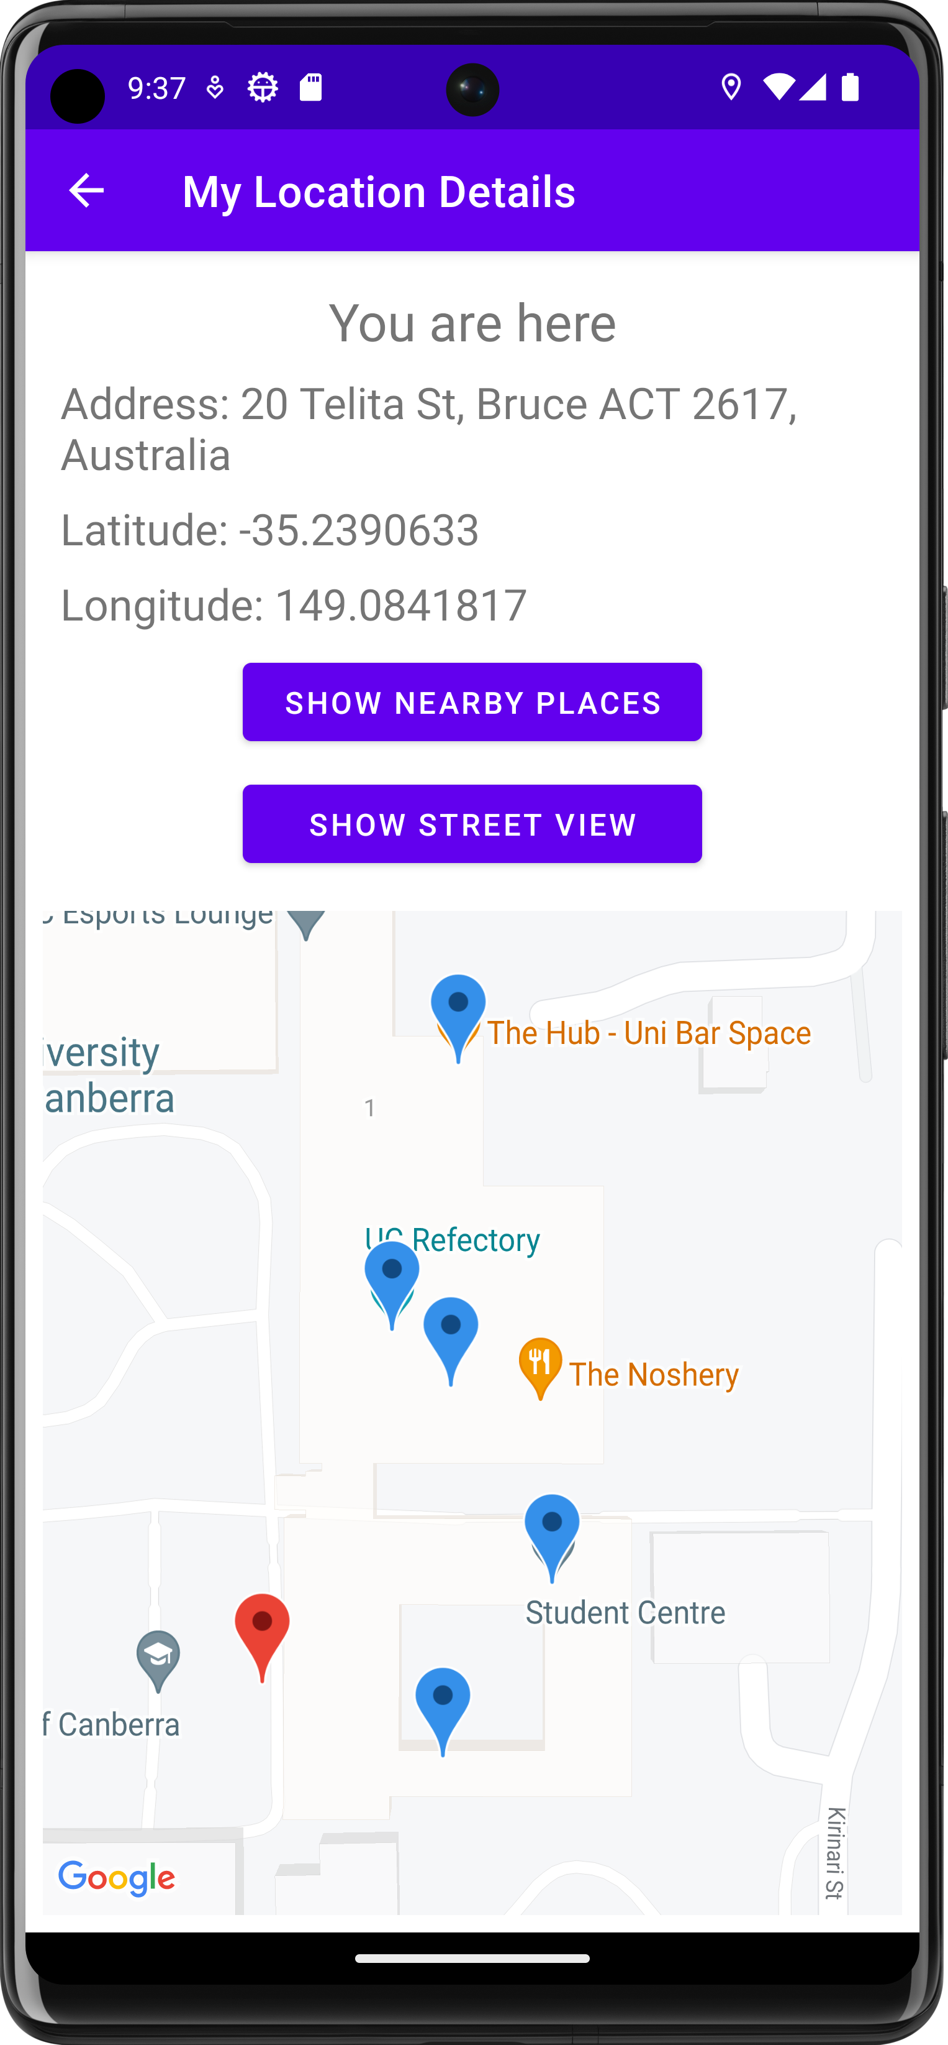 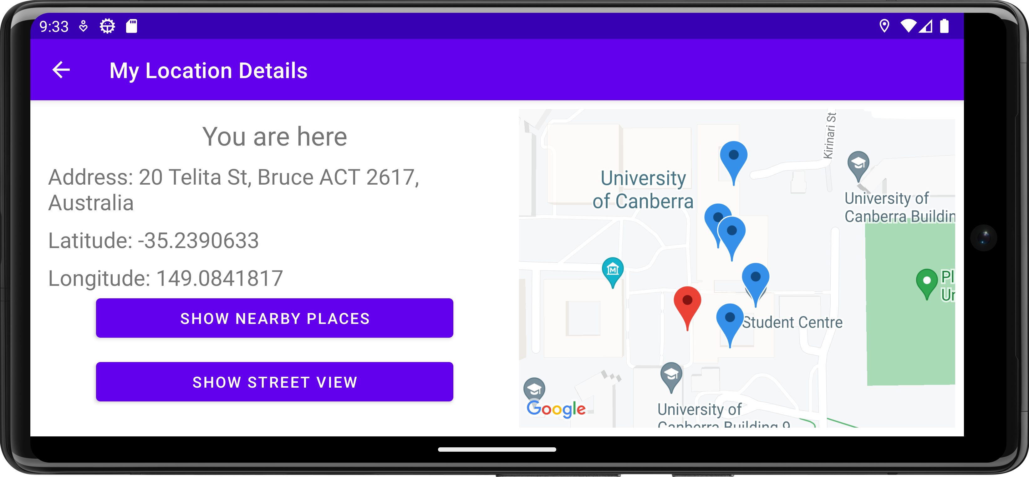

* If the user clicks on any blue marker, the app will show an info window that shows address~~, latitude~~ ~~and longitude~~ and business name as seen in the screenshot below. For example, the user clicks on the top blue marker, it shows an info window with a blue marker icon, the business name (The Hub – Uni Bar Space), and its business address. If the user clicks on this info window, the app will show the street view for that business (The Hub). Note there is no change on the second button.

 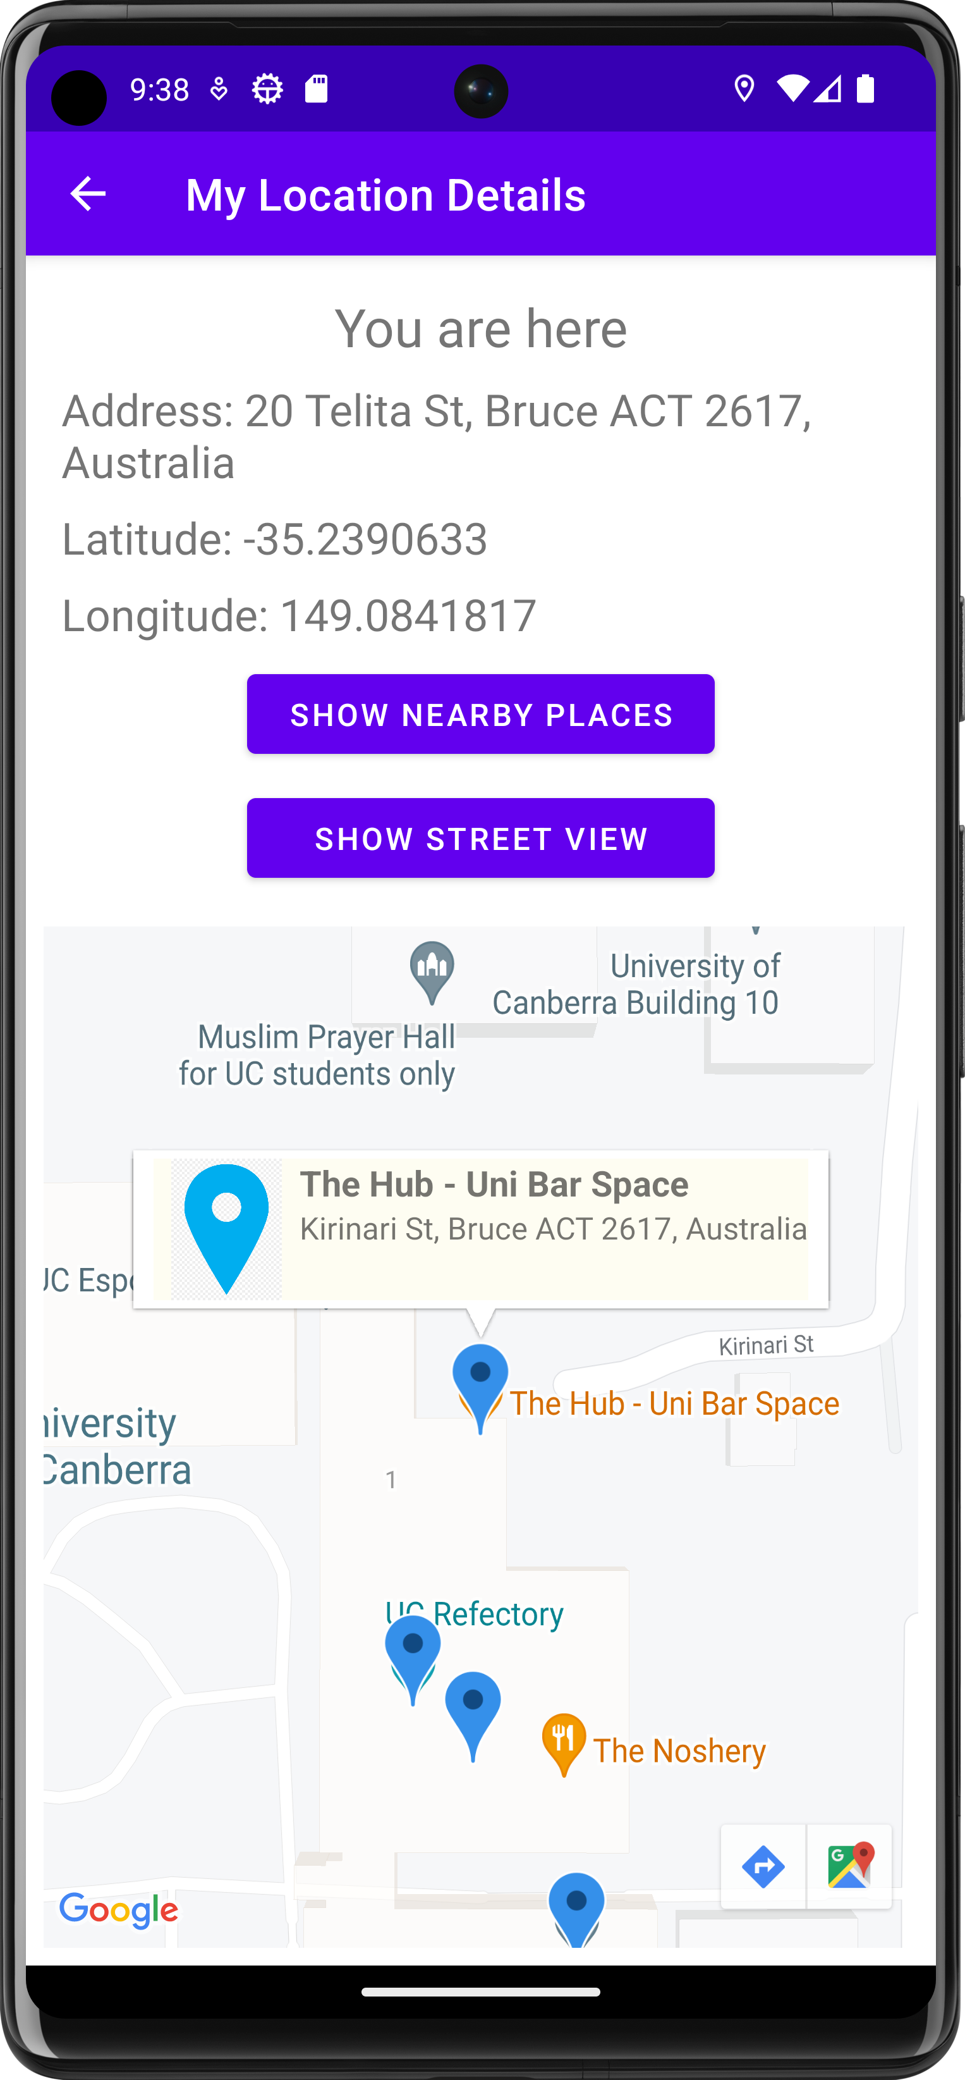 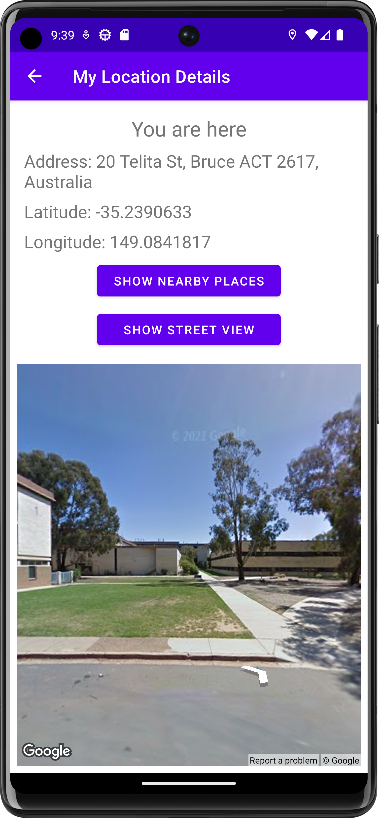

 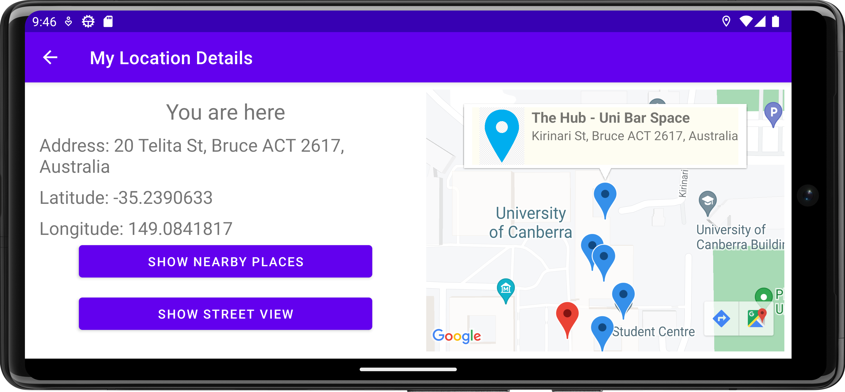

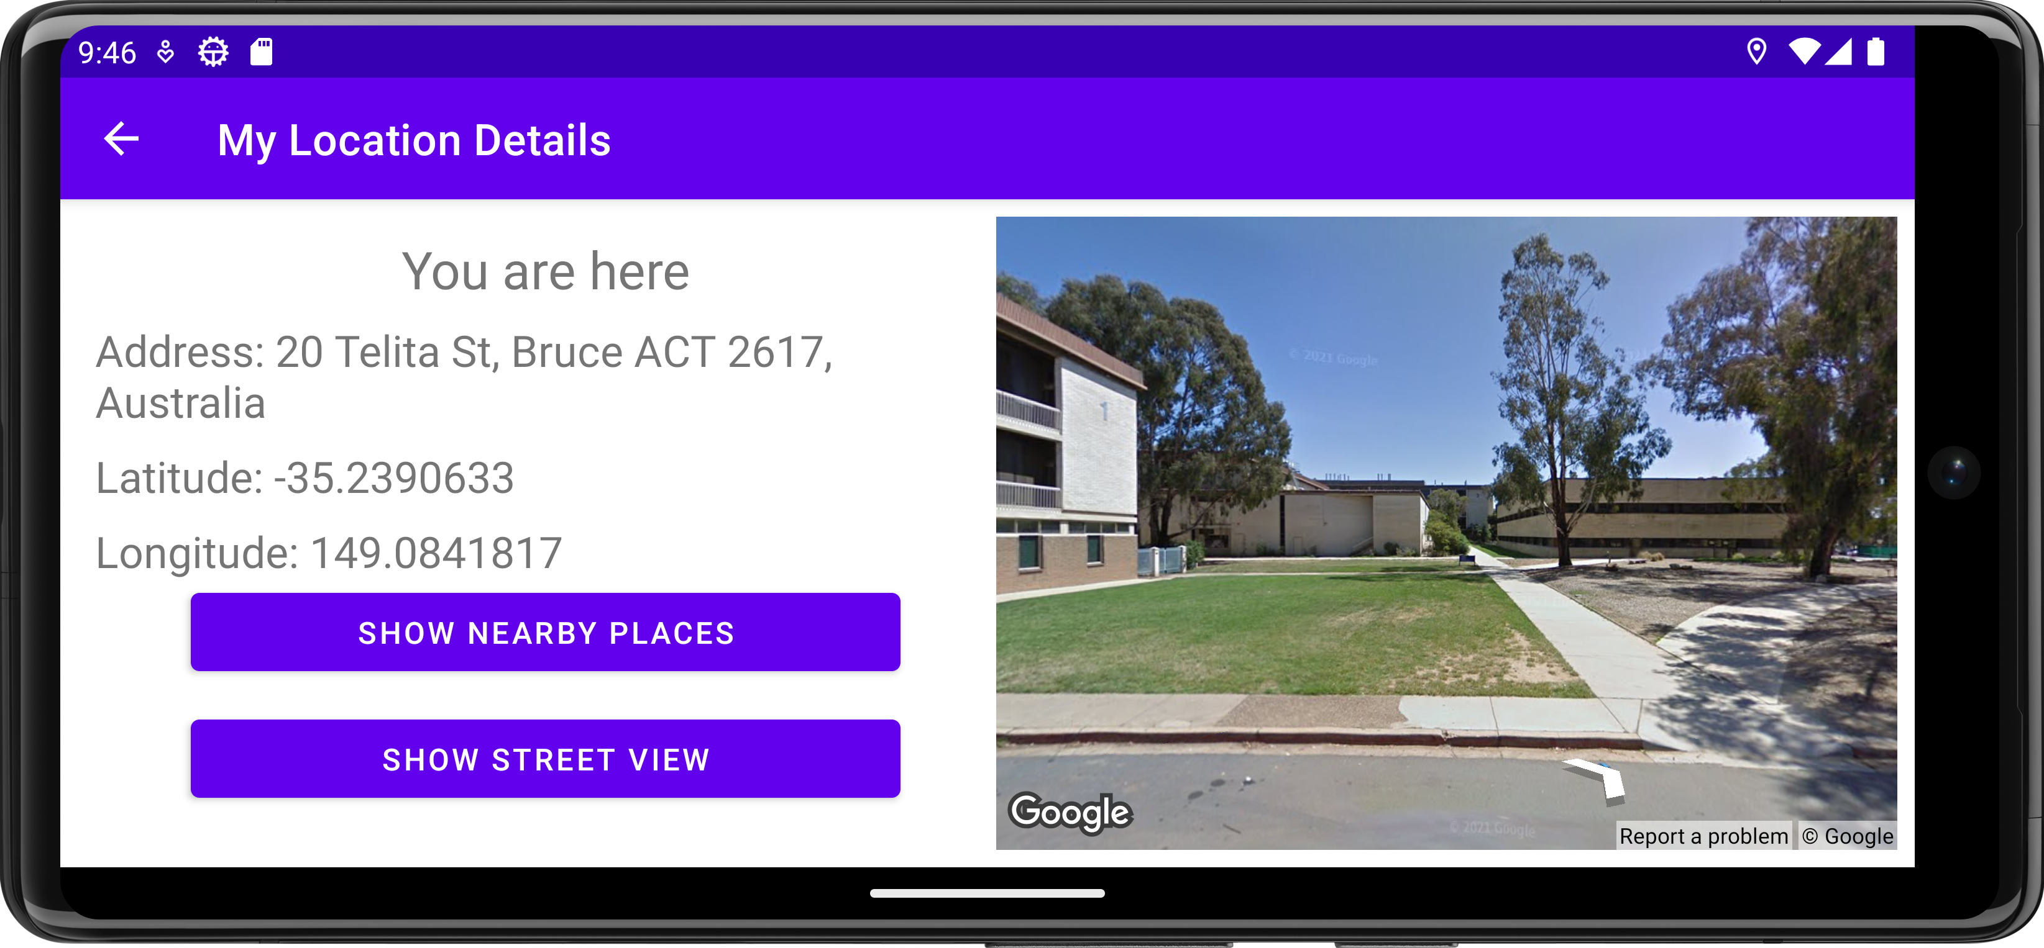

* Now if the user clicks the second button (Show Street View), the app shows the street view for the current location and changes the label of the second button from Show Street View to Show Map.

 

* If the user clicks the back arrow button, the app will show the main activity.

 

 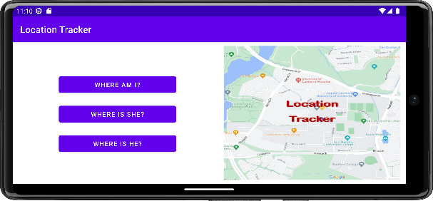

Hints are provided in lectures and tutorials in Weeks 2-5. Marking Rubric is available on Canvas in Week 3. Please review **UC Student Academic Integrity Policy** in the unit outline to avoid plagiarism.